- Unit Root Tests
  - Graphical
    - Linear Trend in ACF
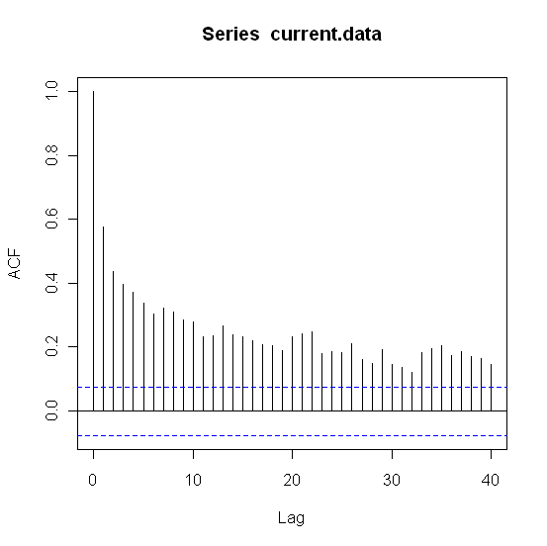
  - Formal
    - ADF w/ lag = 4 (H_{o}: y_{t} ~ I(1), unit root stationary, H_{a}: y_{t} ~ I(0), non unit root stationary)
      - ADF – C
        - Test Statistic = -6.3211
        - P-value = 0.01
      - ADF – NC
        - Test Statistic = -0.3217
        - P-value = 0.5138
      - ADF – CT
        - Test Statistic = -6.6711
        - P-value = 0.01
    - Phillips – Perron (H_{o}: y_{t} ~ I(1), unit root stationary, H_{a}: y_{t} ~ I(0), non unit root stationary)
      - Test Statistic = -14.568
      - P-value = 0.01
      - Truncation lag parameter = 6
    - KPSS (H_{o}: y_{t} ~ I(0), non unit root stationary, H_{a}: y_{t} ~ I(1), unit root stationary)
      - Short truncation lag
        - KPSS Trend = 0.2972
        - P-value = 0.01
        - Truncation lag parameter = 5
      - Long truncation lag
        - KPSS Trend = 0.1437
        - P-value = 0.0542
        - Truncation lag parameter = 18

- ARMA / GARCH
  - ARMA(2,1)

Call:
arima(x = current.data, order = c(2, 0, 1))

Coefficients:
ar1 ar2 ma1 intercept
1.2762 -0.3002 -0.8531 11.4878
s.e. 0.0715 0.0610 0.0537 0.1610

sigma^2 estimated as 0.4878: log likelihood = -703.14, aic = 1416.29

  - GARCH(1,1) with ARMA(2,1)

Maximum Likelihood Estimation (Std.Errors based on Second derivatives)
Coefficient Std.Error t-value t-prob
Cst(M) 11.524248 0.11912 96.75 0.0000
AR(1) 1.000000 1.2918 0.7741 0.4391
AR(2) -0.106731 0.82108 -0.1300 0.8966
MA(1) -0.543666 1.4092 -0.3858 0.6998
Cst(V) 0.184434 0.13202 1.397 0.1629
ARCH(Alpha1) 0.142997 0.060934 2.347 0.0192
GARCH(Beta1) 0.488994 0.28470 1.718 0.0863

